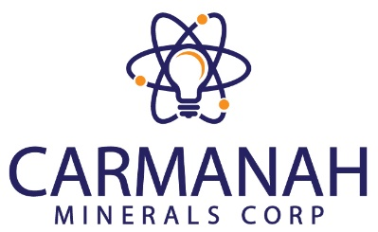
CARMANAH MINERALS CORP.
Suite 1430, 800 West Pender Street
Vancouver, BC, V6C 2V6

NEWS RELEASE CARM: CSE
Carmanah signs joint venture agreement with marvel discovery on its walker uranium claims in the athabasca basin

October 5th, 2022, Vancouver, B.C. – Carmanah Minerals Corp. (CSE: CARM), (“Carmanah” or the “Company”) is pleased to announce that it has signed a joint venture (“JV”) agreement with Marvel Discovery Corp. (“Marvel”) (TSX.V: MARV), to earn a 50% interest in the Walker Claims (the “Property”) located in the Athabasca Basin, Saskatchewan (Figure 1). Upon completion of the earn-in by Carmanah, Marvel and Carmanah would each own 50% of the project with Carmanah funding $1.5 million in exploration expenditures, paying $ 400,000 in cash and the issuance of 3.5 million shares and 3.5 million warrants of the Company over a 3-year period.

"We are very excited to have reached an agreement with Marvel Discovery on this project, it is ideally situated along the Key Lake fault which is home to some of the highest-grade Uranium in the world. The project is also directly tied on to Fission and Cameco’s ground which runs along the Key Lake Shear Zone and hosts 10 Uranium showings and multiple EM Targets. This corridor represents a tremendous opportunity in mimicking the success of basement-hosted uranium deposits found on the western side of the Athabasca Basin like NexGen Energy’s Arrow Deposit. Marvel has done a remarkable job advancing the project and we look forward to working with our new partner with the goal of a Tier 1 Discovery,” stated Latika Prasad, Chief Executive Officer of the Company.”

The Walker and KLR Properties lie within the Wollaston-Mudjactic transition zone (WMTZ) of the eastern Athabasca basin, which is host to the highest-grade uranium mines in the world, including:

The WMTZ hosts the highest-grade uranium mines in the world including (Figure 1):

- Cigar Lake¹, 50% owned by Cameco, which hosts reserves of 221.6 million pounds (lbs.) of U₃O₈ at 16.7% U₃O₈
- McArthur River², 70% owned by Cameco which hosts reserves of 392 million lbs. of U₃O₈ at 6.91% U₃O₈
- Wheeler Project³, 90% owned by Denison Mines which hosts reserves of 109 million lbs. of U₃O₈ in two deposits averaging 11.23% U₃O₈.

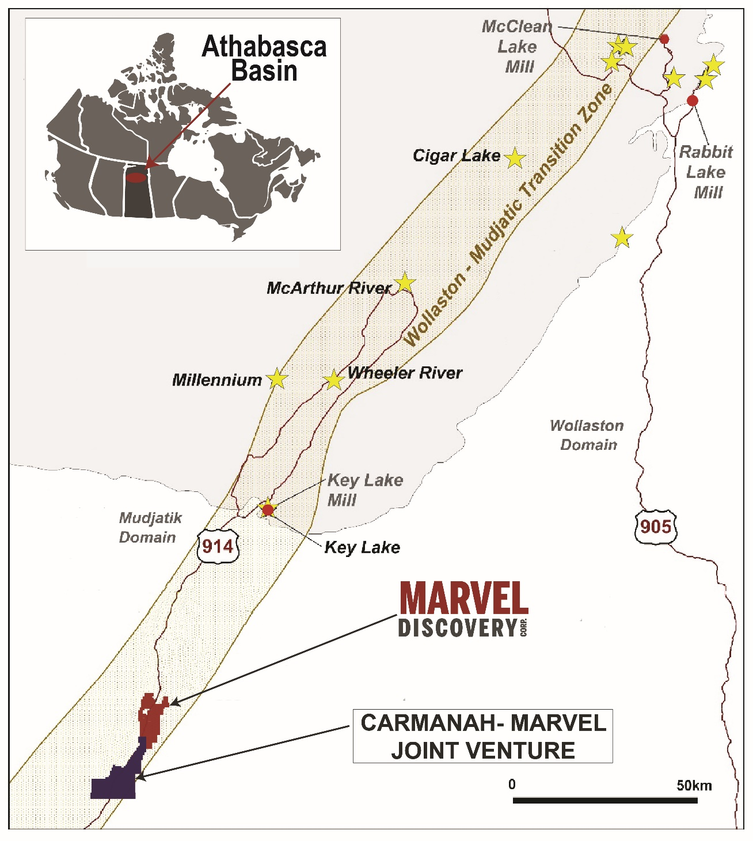
Figure 1. Location of the Walker- KLR Uranium Project in the WMTZ Zone host to the highest-grade uranium deposits in the world.
Regional Geology and Mineralization
In Saskatchewan, uranium deposits have been discovered at, above and up to 300 metres below the Athabasca group unconformity within basement rocks. Mineralization can occur hundreds of metres into the basement or can be up to 100 metres above in Athabasca group sandstone. Typically, uranium is present as uraninite/pitchblende that occurs as veins and semi-massive to massive replacement bodies. Mineralization is also spatially associated with steeply dipping, graphitic basement structures and may have been remobilized during successive structural reactivation events. Such structures can be important fluid pathways as well as structural or chemical traps for mineralization as reactivation events have likely introduced further uranium into mineralized zones and provided a means for remobilization (Jefferson, et al. 2007) (Figure 2).
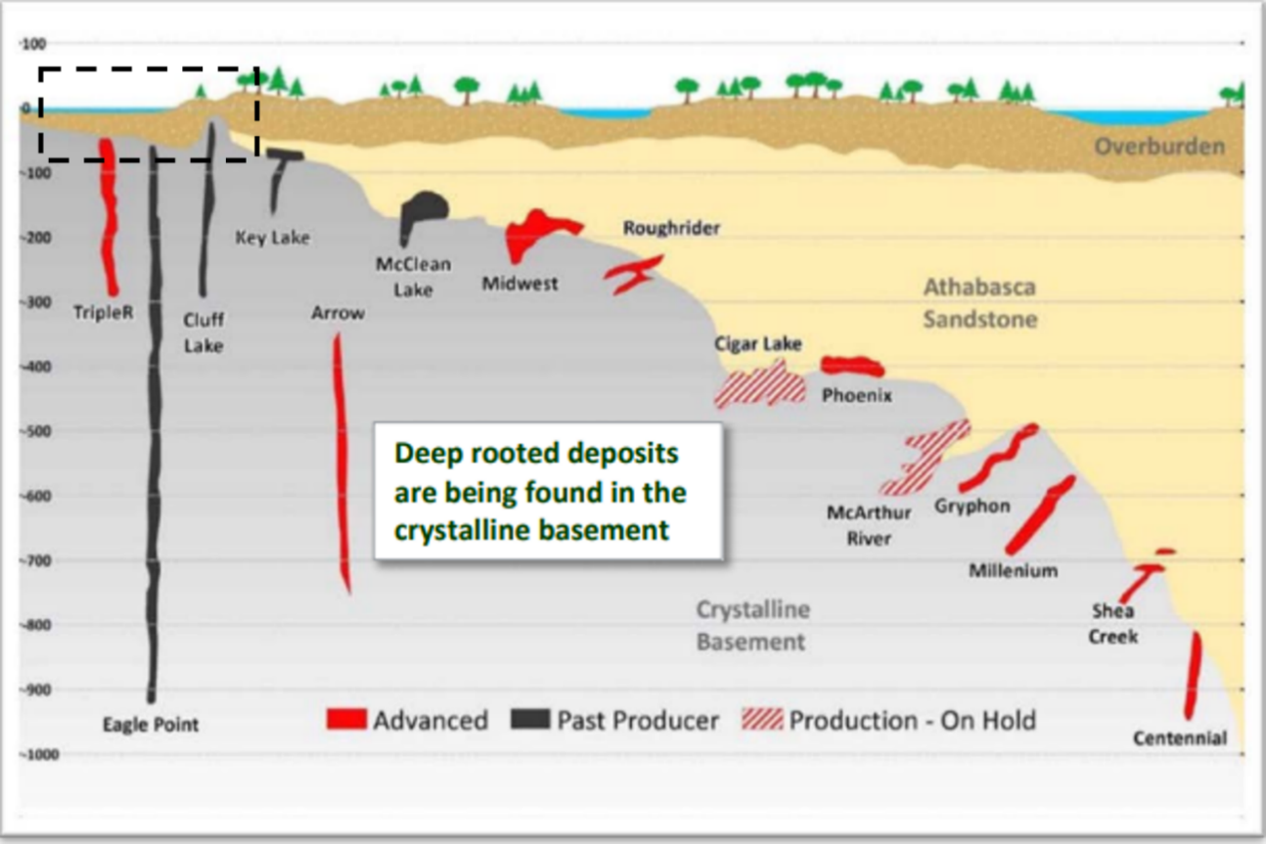
Figure 2. Classic uranium deposits of the Athabasca Basin at the unconformity between the Athabasca sandstone and crystalline basement within the WMTZ. The Triple R, Eagle Point, Cluff Lake and Arrow deposits are found within basement rocks of the Crystalline Granulite Domain in the western Athabasca Basin. The KLR and Walker properties lie within the basement rocks just south of the former Key Lake Mine within the WMTZ. Source Searchlight Resources.
Marvel still controls 100% of the Highway North and KLR claims (Figure 3). These claim groups straddle the Key Lake fault zone, an important corridor for structurally controlled Athabasca-basin-type uranium deposits. The Arrow deposit⁴, owned by NexGen Energy, lies along a similar structural corridor as the Marvel properties. The Arrow deposit, which has undergone a positive feasibility study with robust economics contains probable reserves of 239.6 million pounds of U₃O₈ at an average of 2.37% U₃O₈ and measured and indicated resources of 256.7 million pounds at an average grade of 3.1% U₃O₈. The Arrow deposit is the largest undeveloped uranium deposit in Canada.
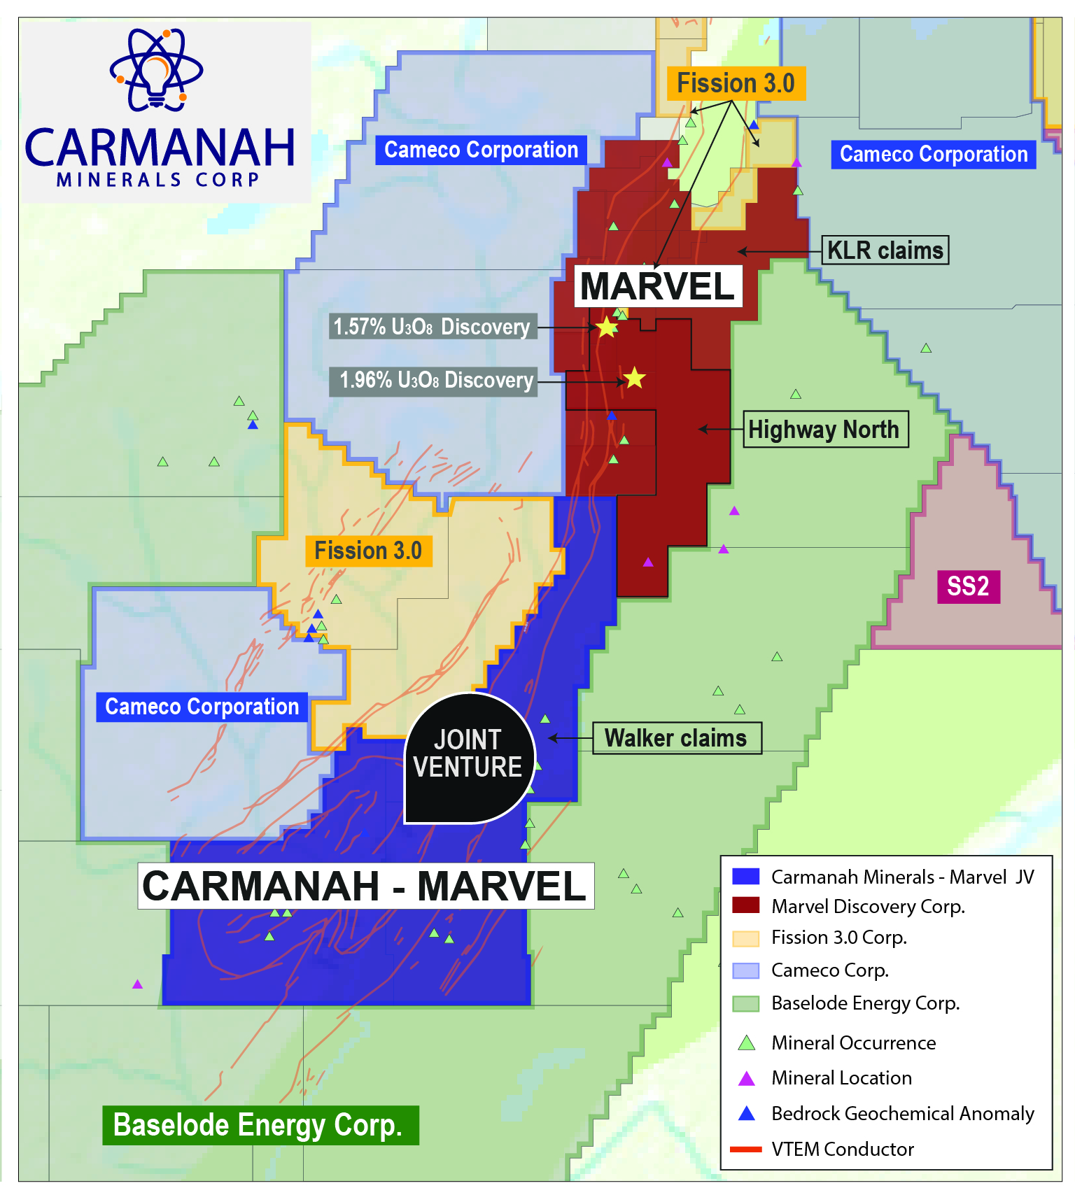
Figure 3. Location of Walker JV and the Highway North and KLR claim groups along the Key Lake Fault with prominent VTEM conductor trends.
Qualified Person
Mike Kilbourne, P. Geo, an independent qualified person as defined in National Instrument 43-101, has reviewed, and approved the technical contents of this news release on behalf of the Company.
References
Jefferson, C.W., Thomas, D.J., Gandhi, S.S., Ramaekers, P., Delaney, G., Brisbin, D., Cutts, C., Portella, P., and Olson, R.A. 2007. Unconformity-associated uranium deposits of the Athabasca Basin, Saskatchewan and Alberta. In EXTECH IV: Geology and Uranium Exploration Technology of the Proterozoic Athabasca Basin. Edited by C.W. Jefferson and G. Delaney. Geological Survey of Canada, Bulletin 588, pp. 23–68.
Cigar Lake¹ : Cigar Lake Operation, Northern Saskatchewan, Canada, Report date March 29, 2016, Prepared by C. Scott Bishop, P.Eng., Alain G. Mainville, P.Geo. and Leslie D. Yesnik, P.Eng.
McArthur River² : McArthur River Operation, Northern Saskatchewan, Canada, Report date March 29, 2019, Prepared by Linda Bray, P.Eng., Gregory M. Murdoch, P.Eng. and Alain D. Renault, P.Eng.
Wheeler Project³ : Prefeasibility Study Report for the Wheeler River Uranium Project, Saskatchewan, Canada, Effective date September 24, 2018, prepared by SRK Consulting.
Arrow Deposit⁴ : Arrow Deposit, Rook I Project, Saskatchewan, NI 43-101 Technical Report on Feasibility Study, Effective date February 22, 2021, prepared by Stantec, Wood and RPA.

About Carmanah Minerals Corp.

Carmanah is focused on mineral exploration in Canada. It is currently actively exploring the Loljuh project, located in the Omineca mining division in British Columbia.

For further information, please view the Company’s filings at www.sedar.com.

ON BEHALF OF THE BOARD

Latika Prasad

Chief Executive Officer and Director

Email: latika@spardacorp.com

Telephone: +1 (604) 802-8492

Disclaimer for Forward-Looking Information:

Certain statements in this release are forward-looking statements which reflect the expectations of management. Forward-looking statements consist of statements that are not purely historical, including any statements regarding beliefs, plans, expectations, or intentions regarding the future. Forward-looking statements in this press release relate to, among other things: completion of the proposed Arrangement. Actual future results may differ materially. There can be no assurance that such statements will prove to be accurate, and actual results and future events could differ materially from those anticipated in such statements. There is no assurance any of the conditions for closing will be met. Forward-looking statements reflect the beliefs, opinions, and projections on the date the statements are made and are based upon a number of assumptions and estimates that, while considered reasonable by the respective parties, are inherently subject to significant business, economic, competitive, political and social uncertainties and contingencies. Readers should not place undue reliance on the forward-looking statements and information contained in this news release concerning these times. Except as required by law, the Company does not assume any obligation to update the forward-looking statements of beliefs, opinions, projections, or other factors, should they change, except as required by law

Neither Canadian Securities Exchange, TSX Venture Exchange nor its Regulation Services Provider (as that term is defined in the policies of the TSX Venture Exchange) accepts responsibility for the adequacy or accuracy of this release.

